**DAILY ONLINE ACTIVITIES SUMMARY**

|  |  |  |  |  |  |  |  |  |
| --- | --- | --- | --- | --- | --- | --- | --- | --- |
| **Date:** | **27/05/2020** | | | | | **Name:** | **Lavanya D M** | |
| **Sem & Sec** | **4th & ‘A’** | | | | | **USN:** | **4AL18CS041** | |
| **Online Test Summary** | | | | | | | | |
| **Subject** | | **OOC** | | | | | | |
| **Max. Marks** | | **30** | | **Score** | | | **29** | |
| **Certification Course Summary** | | | | | | | | |
| **Course** | **GIT tutorial for beginner** | | | | | | | |
| **Certificate Provider** | | | **Bitdegree** | | **Duration** | | | **48hr** |
| **Coding Challenges** | | | | | | | | |
| **Problem Statement:1)** Write a C Program to sort an array of integers in ascending order and display the sorted array and Number of passes performed for sorting  2) find the largest element on the left side of each index which is smaller than the element present at that index. | | | | | | | | |
| **Status: Complied** | | | | | | | | |
| **Uploaded the report in GitHub** | | | | | **Yes** | | | |
| **If yes Repository name** | | | | | <https://github.com/lavanyamurthi/lockdown-coding> | | | |
| **Uploaded the report in slack** | | | | | **Yes** | | | |

Online Test Details: (Attach the snapshot and briefly write the report for the same)

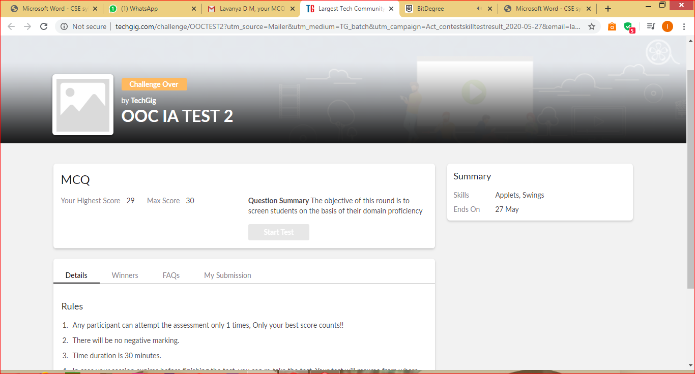

Certification Course Details: (Attach the snapshot and briefly write the report for the same)

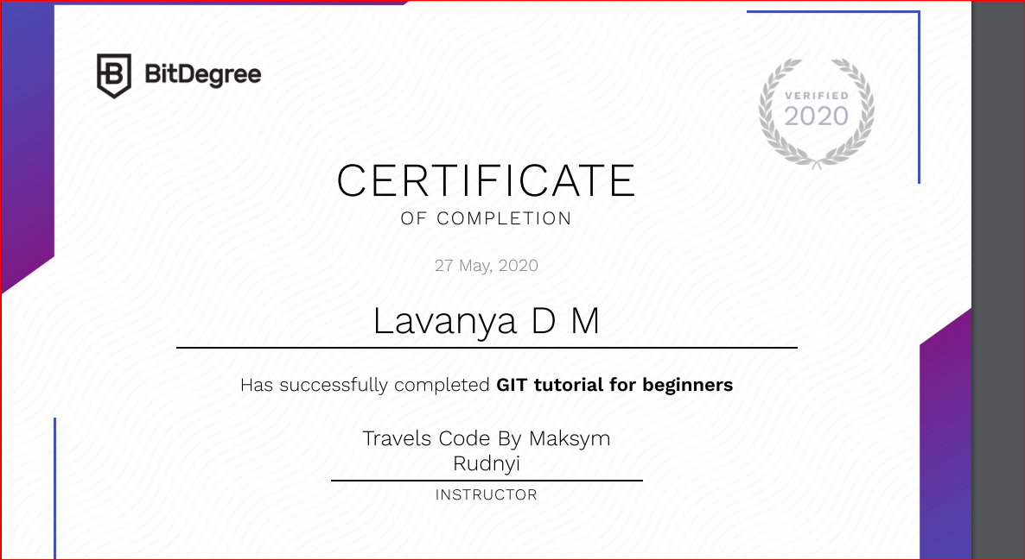

I had successfully completed the GIT tutorial for beginner course even I uploaded in GitHub here is the link

<https://github.com/lavanyamurthi/lockdown-certificate/blob/master/27maycerti.PNG>

Coding Challenges Details: (Attach the snapshot and briefly write the report for the same)

Problem1:

In Bubble sort, each pass consists of comparison each element in the file with its successor (i.e. x[i] with x[i+1]) and interchanging two elements if they are not in the proper order. The array may be sorted in any pass. If the array is sorted, then remaining passes should be skipped off. Write a C Program to sort an array of integers in ascending order and display the sorted array and Number of passes performed for sorting.

<https://github.com/lavanyamurthi/lockdown-coding/blob/master/bubblesort.c>

the above is the GitHub repository link

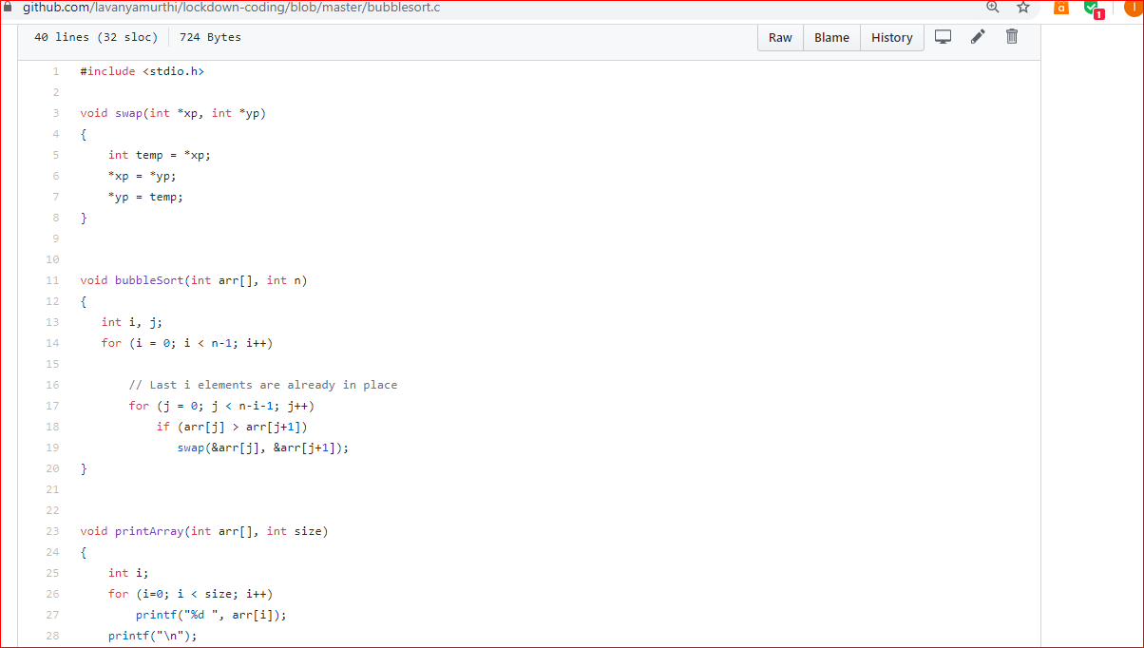

Problem2: Given an array arr[] of the positive integers of size N, the task is to find the largest element on the left side of each index which is smaller than the element present at that index. Note: If no such element is found then print -1..

Input: arr[] = {2, 5, 10}  
Output: -1 2 5  
Explanation :  
Index 0: There are no elements before it  
So Print -1 for the index 0  
Index 1: Elements less than before index 1 are – {2}  
Maximum of those elements is 2  
Index 2: Elements less than before index 2 are – {2, 5}  
Maximum of those elements is 5

Input: arr[] = {4, 7, 6, 8, 5}  
Output: -1 4 4 7 4  
Explanation :  
Index 0: There are no elements before it  
So Print -1 for the index 0  
Index 1: Elements less than before index 1 are – {4}  
Maximum of those elements is 4  
Index 2: Elements less than before index 2 are – {4}  
Maximum of those elements is 4  
Index 3: Elements less than before index 3 are – {4, 7, 6}  
Maximum of those elements is 7  
Index 4: Elements less than before index 4 are – {4}  
Maximum of those elements is 4

<https://github.com/lavanyamurthi/lockdown-coding/blob/master/largest_element.c>

the above is the GitHub repository link

